**Ideation Phase**

**Define the Problem Statements**

|  |  |
| --- | --- |
| Date | 08 September 2022 |
| Team ID | PNT2022TMID23612 |
| Project Name | A novel method for Handwritten digit  recognition system |
| Maximum Marks | 2 Marks |

**PROBLEM STATEMENT 1:**

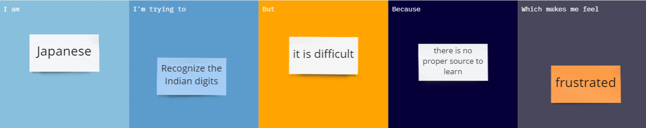

**PROBLEM STATEMENT 2**:

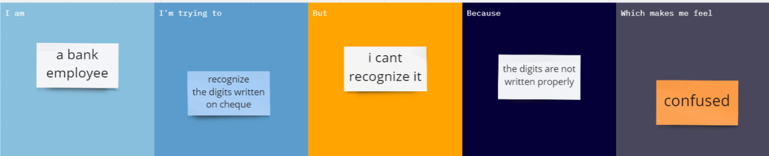

**PROBLEM STATEMENT 3**:

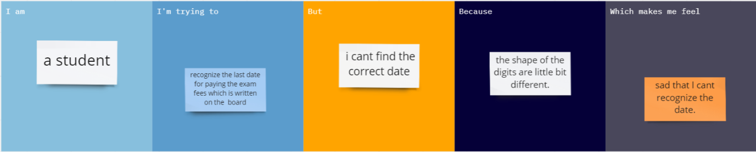

**PROBLEM STATEMENT 4**:

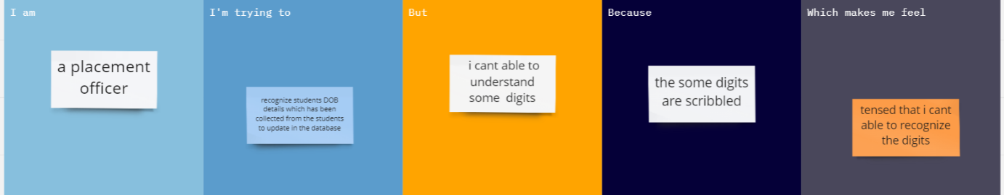

|  |  |  |  |  |  |
| --- | --- | --- | --- | --- | --- |
| **Problem Statement (PS)** | **I am (Customer)** | **I’m trying to** | **But** | **Because** | **Which makes me feel** |
| PS-1 | Japanese | Recognize the Indian digits | It is difficult | There is no proper source to learn | Frustrated |
| PS-2 | A bank employee | Recognize the digit written on cheque | I can’t recognize it | The digits are not written properly | Confused |
| PS-3 | A student | recognize the last date for paying the exam fees which is written on the board | I can’t find the correct date | The shapes of the digits are a little bit different. | Sad that I can’t recognize the date |
| PS-4 | a placement officer | recognize students’ DOB details which have been collected from the students to update the database | I can’t able to understand some digits | Some digits are scribbled | Tensed that I can’t able to recognize the digits |